POI 7 & 8:

Can ya’ll take a look at these two points coming in as not extended:

GUIDs:

|  |
| --- |
| 58fc4b77-ed52-410e-81d9-be7137ba2b33 |
| a95223e4-d46f-4b5d-9829-5cf31987277a |

I did try removing and replacing them but can’t really understand why else they don’t get caught with the extended Boolean.

POI 23-30:

These points seem to be pulling the wrong multiplicative equations per the flowchart.

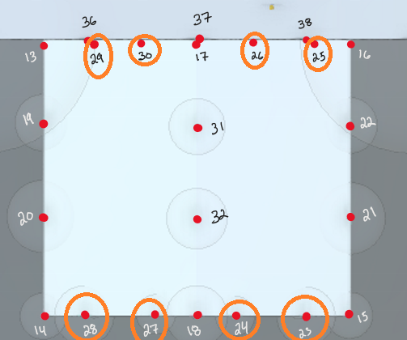

Some of these should be pulling extended and aren’t (23, 24, 27, 28)

POI 36-38:

Seems to be pulling wrong equations again here.

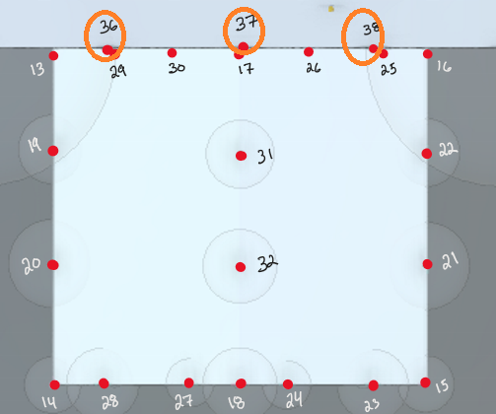

These aren’t extended points so should just be pulling GRN equations (not level zero or not extended -> EQ G).

POIs 41-43:

Should be extended points but aren’t grabbing the Boolean.

